1. **PROGRAMS USING STRINGS**

**1.Program to print the accepted string.**

/*Program to print accepted string*/

#include<stdio.h>

#include<conio.h>

main()

{

char ch[30];

clrscr();

printf("Enter String: ");

gets(ch);

printf("\nEntered String: ");

puts(ch);

}

**Output:**

Enter String: C is a good language.

Entered String: C is a good language.

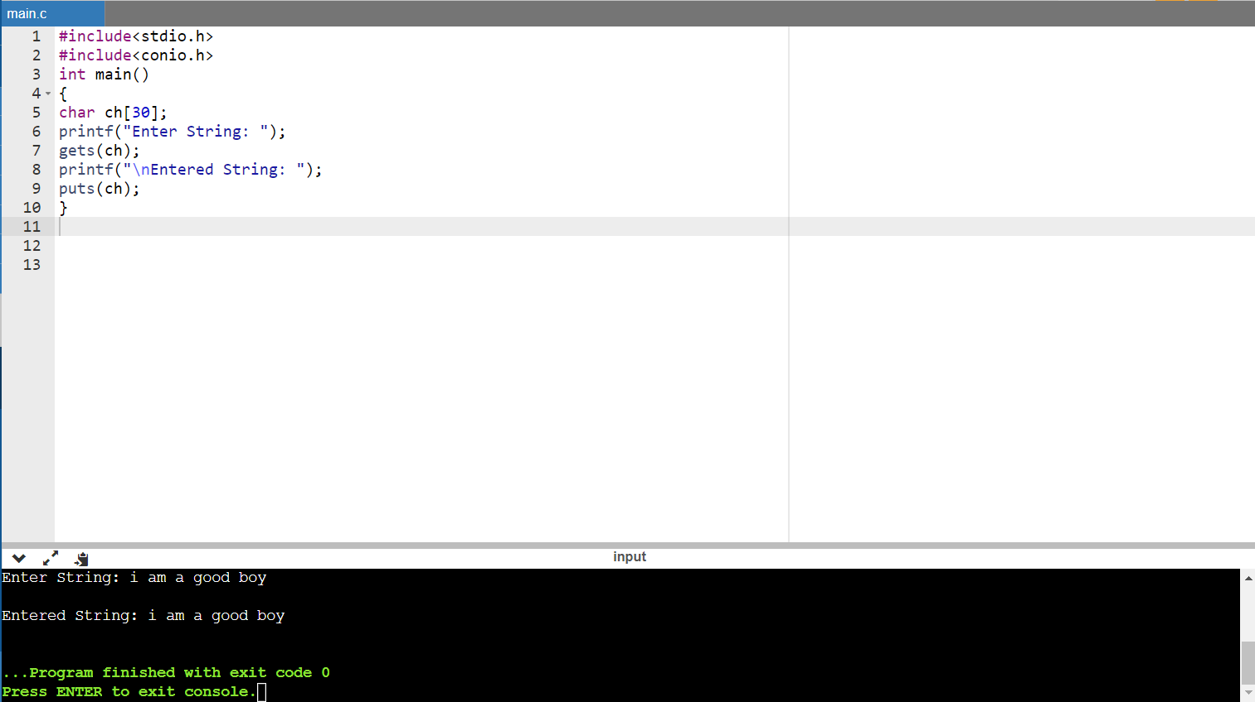

**2.Program to read integer and character**

/*Program to read integer and character*/

#include<stdio.h>

main()

{

char ch;

int a;

clrscr();

printf("Enter Integer value: ");

scanf("%d",&a);

fflush(stdin);

printf("Enter character value: ");

ch=getchar();

printf("\nEntered integer = %d \tEntered character = %c",a,ch);

}

**Output:**

Enter Integer value: 22

Enter character value: k

Entered integer = 22 Entered character = k

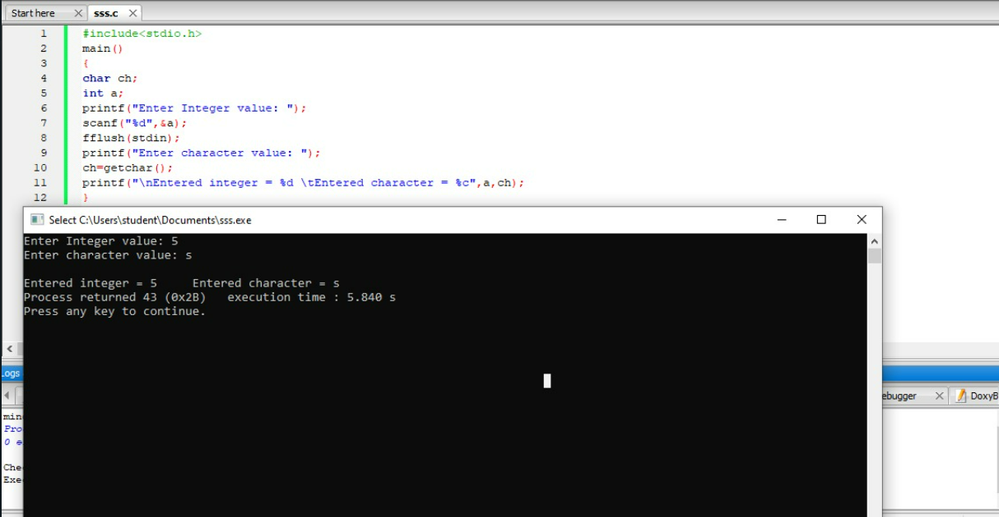

**3. Program to find length of the string using strlen() function.**

#include<stdio.h>

#include<string.h>

main()

{

char name[100];

int length;

printf("Enter a string: ");

gets(name);

length = strlen(name);

printf("\nNumber of characters in the string is %d",length);

getch();

}

**Output:**

Enter a string: peter

Number of characters in the string is 5

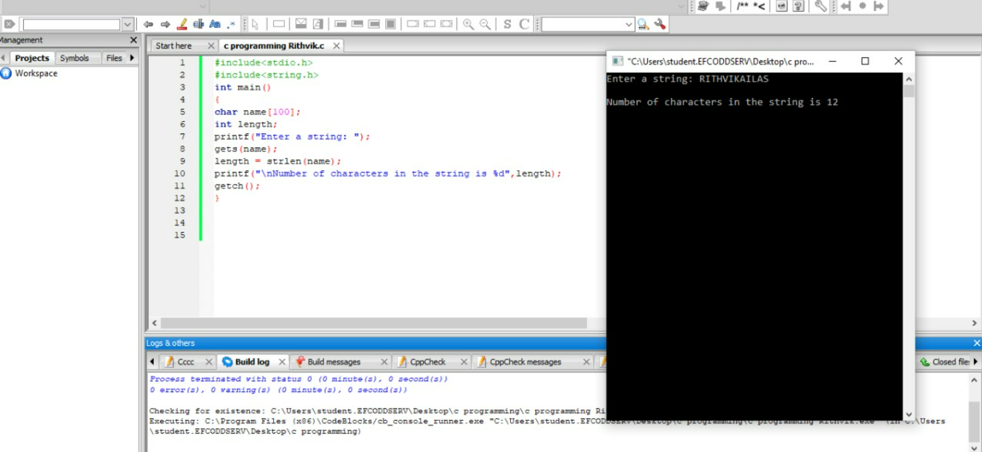

**4. Program to convert lowercase to uppercase and uppercase to lowercase.**

#include<stdio.h>

#include<string.h>

main()

{

char name[100];

clrscr();

printf("Enter a string: ");

gets(name);

printf("\nUppercase String: ");

puts(strupr(name));

strlwr(name);

printf("\nLowercase String: ");

puts(name);

getch();

}

**Output:**

Enter a string: peter

Uppercase String: PETER

Lowercase String: peter

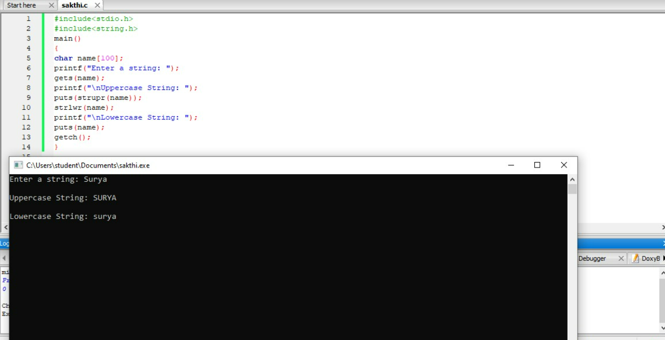

**5. Program to check whether given string is palindrome or not.**

#include<stdio.h>

#include<string.h>

main()

{

char name1[20],name2[20];

clrscr();

printf("Enter a string: ");

gets(name1);

strcpy(name2,name1);

strrev(name2);

printf("Reversed String is ",name2);

if(strcmp(name1,name2) == 0)

printf("String is Palindrome");

else

printf("String is Not Palindrome");

getch();

}

**Output:**

Enter a string: peter

Reversed String: retep

String is not Palindrome

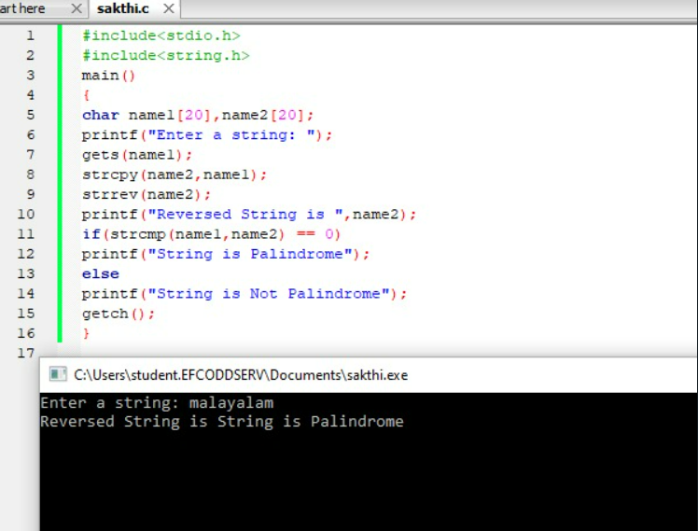

**6.Program to sort an array of 10 strings**

#include<stdio.h>

#include<string.h>

main()

{

char names[10][20];

int i,j;

char temp[20];

clrscr();

printf("Enter array of strings:\n");

for(i=0;i<10;i++)

gets(names[i]);

for(i=0;i<9;i++)

for(j=i+1;j<10;j++)

if(strcmp(names[i],names[j])>0)

{

strcpy(temp,names[i]);

strcpy(names[i],names[j]);

strcpy(names[j],temp);

}

printf("Sorted array of strings: \n");

for(i=0;i<10;i++)

puts(names[i]);

}

**Output:**

Enter array of strings:

santosh

anand

praneeth

manohar

naidu

hari

rajesh

aditya

julie

pavan

Sorted array of strings:

aditya

anand

hari

julie

manohar

naidu

pavan

praneeth

rajesh

santosh

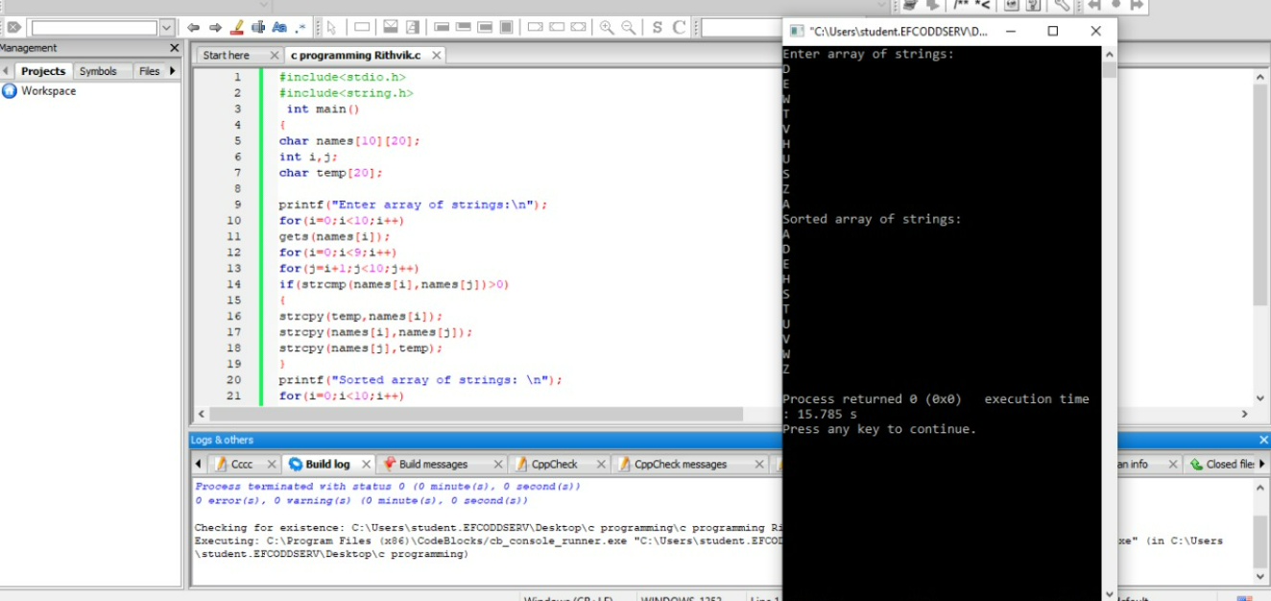

**7. Program to read a line of text**

#include<stdio.h>

main()

{

char line[81],character;

int c=0;

clrscr();

printf("Enter text. Press Enter at end\n");

do {

character = getchar();

line[c] = character;

c++;

}

while(character!='\n');

c=c-1;

line[c] = '\0';

printf("\n%s\n",line);

getch();

}

**Output:**

Enter text. Press Enter at end

This program reads a string and prints.

This program reads a string and prints.

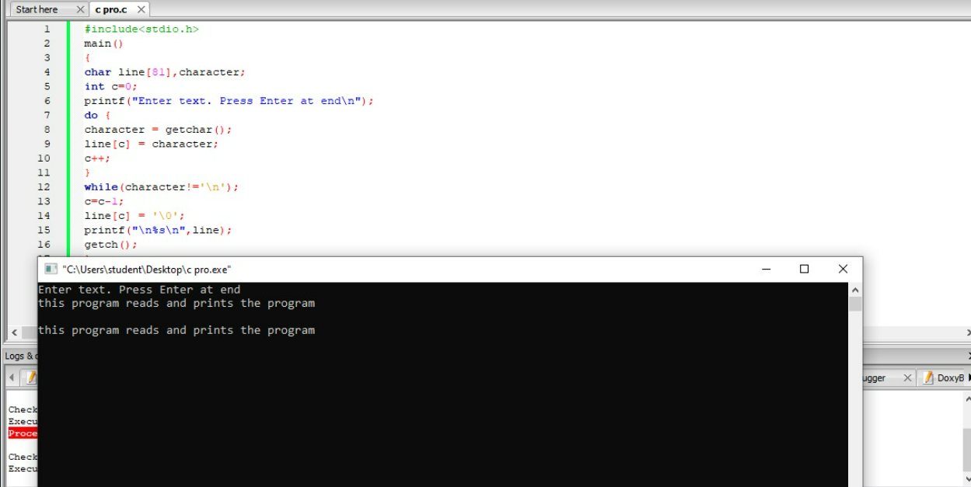

**8. Program to Accept a string and display string in uppercase.**

#include<stdio.h>

main()

{

char st[20];

int i;

clrscr();

/* accept a string */

printf("Enter a string: ");

gets(st);

/* display it in upper case */

for ( i = 0 ; st[i] != '\0'; i++)

if ( st[i] >= 'a' && st[i] <= 'z' )

putch( st[i] - 32);

else

putch( st[i]);

getch();

}

**Output:**

Enter a string: c programming

C PROGRAMMING

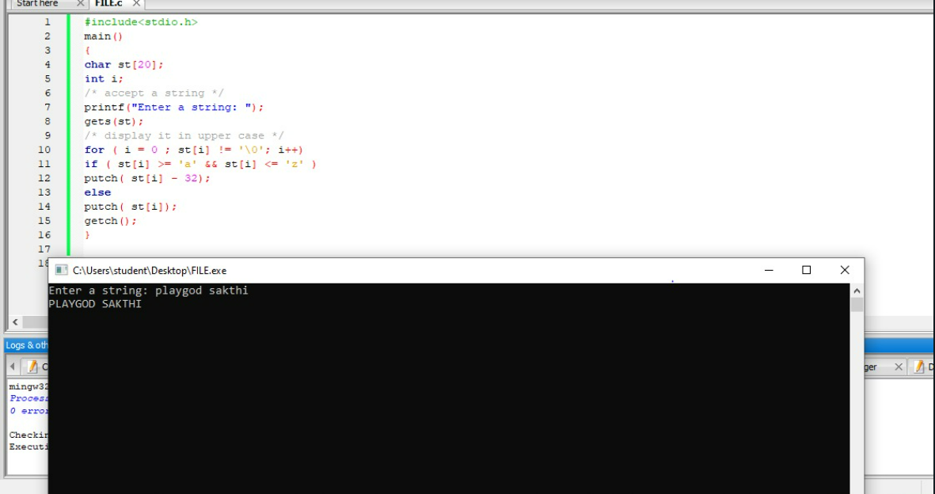

**9. Program to write string using %s format.**

#include<stdio.h>

main()

{

char country[15]="United Kingdom";

clrscr();

printf("\n\n");

printf("-------------------\n");

printf("|%15s|\n",country);

printf("|%5s|\n",country);

printf("|%15.6s|\n",country);

printf("|%.6s|\n",country);

printf("|%15.0s|\n",country);

printf("|%.3s|\n",country);

printf("|%s|\n",country);

printf("------------------\n");

getch();

}

**Output:**

------------------

| United Kingdom|

|United Kingdom|

| United|

|United|

| |

|Uni|

|United Kingdom|

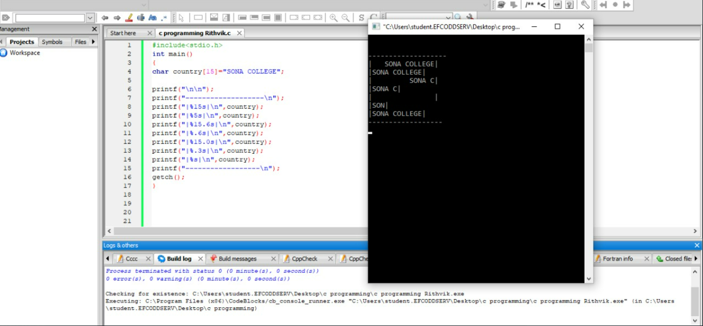

**10. Program to find length of the string.**

#include<stdio.h>

main()

{

char str[20];

int i = 0;

clrscr();

printf("\nEnter any string: ");

gets(str);

while (str[i] != '\0')

i++;

printf("\nLength of string: %d", i);

getch();

}

**Output:**

Enter any string: ANIL NEERUKONDA

Length of string: 15

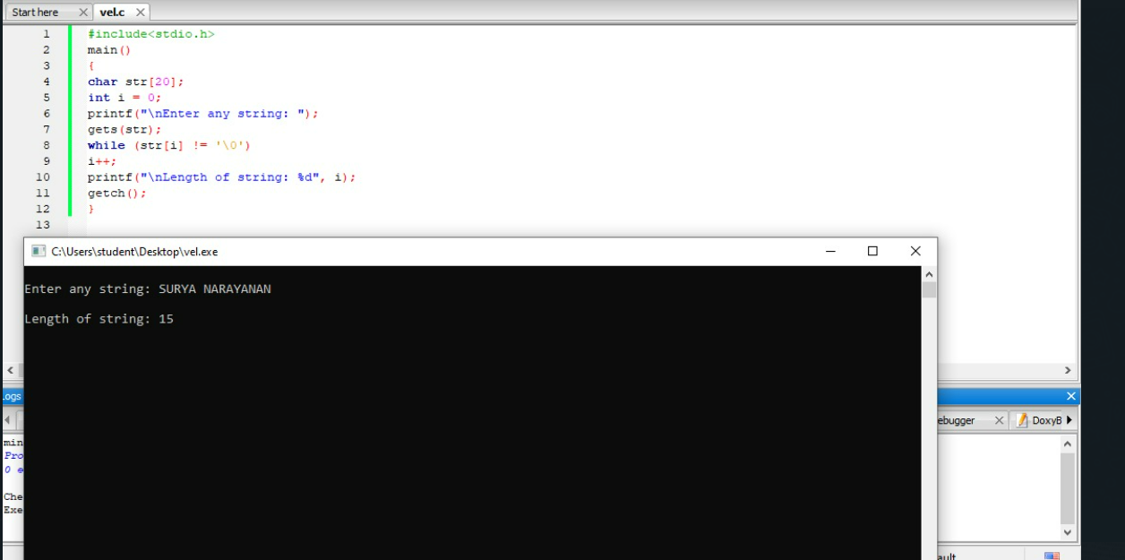

**11.Program to accept a string and display it in reverse.**

#include<stdio.h>

main()

{

char st[20];

int i;

clrscr();

printf("Enter a string: "); /* accept a string */

gets(st);

/* get length of the string */

for ( i = 0 ; st[i] != '\0'; i++);

/* display it in reverse order */

for ( i -- ; i >= 0 ; i --)

putch(st[i]);

getch();

}

**Output:**

Enter a string: HELLO WORLD

DLROW OLLEH

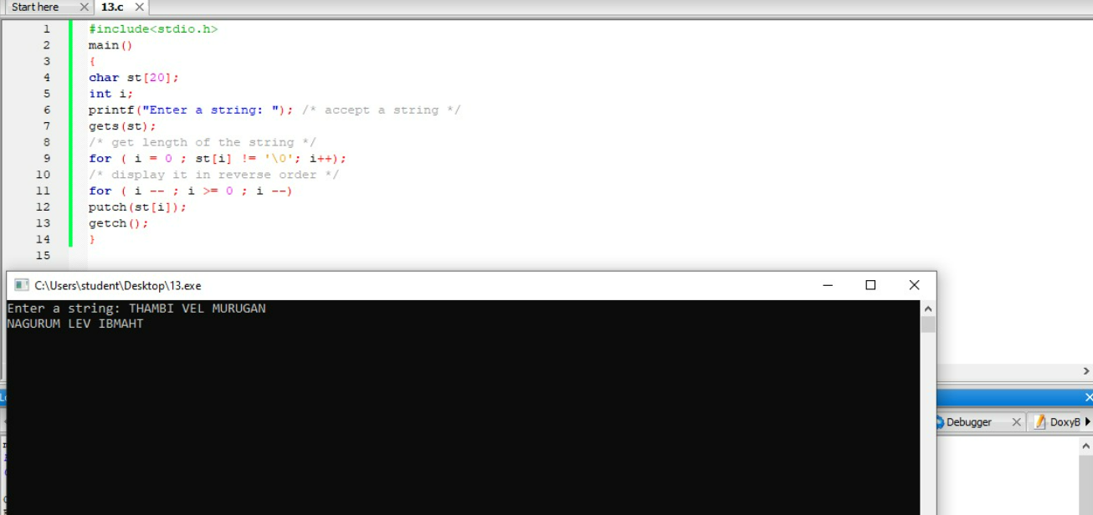

**12.Program to Concatenate of 2 Strings**

#include<stdio.h>

#include<conio.h>

main()

{

char string1[30], string2[20];

int i, length=0, temp;

printf("Enter the Value of String1: \n");

gets(string1);

printf("\nEnter the Value of String2: \n");

gets(string2);

for(i=0; string1[i]!='\0'; i++)

length++;

temp = length;

for(i=0; string2[i]!='\0'; i++)

{

string1[temp] = string2[i];

temp++;

}

string1[temp] = '\0';

printf("\nThe concatenated string is:\n");

puts(string1);

getch();

}

**Output:**

Enter the Value of String1:

C Language

Enter the Value of String2:

is good

The concatenated string is:

C Language is good

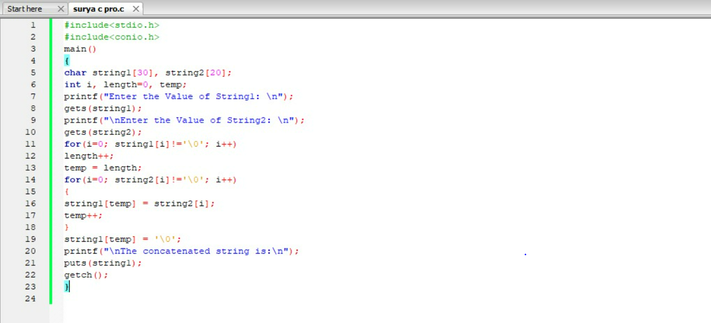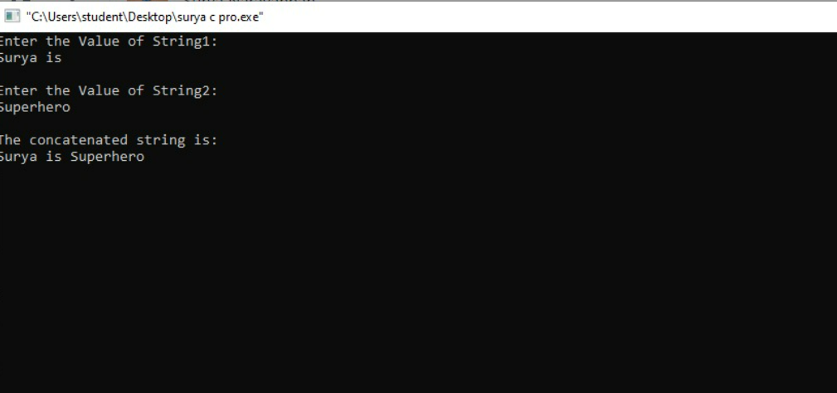

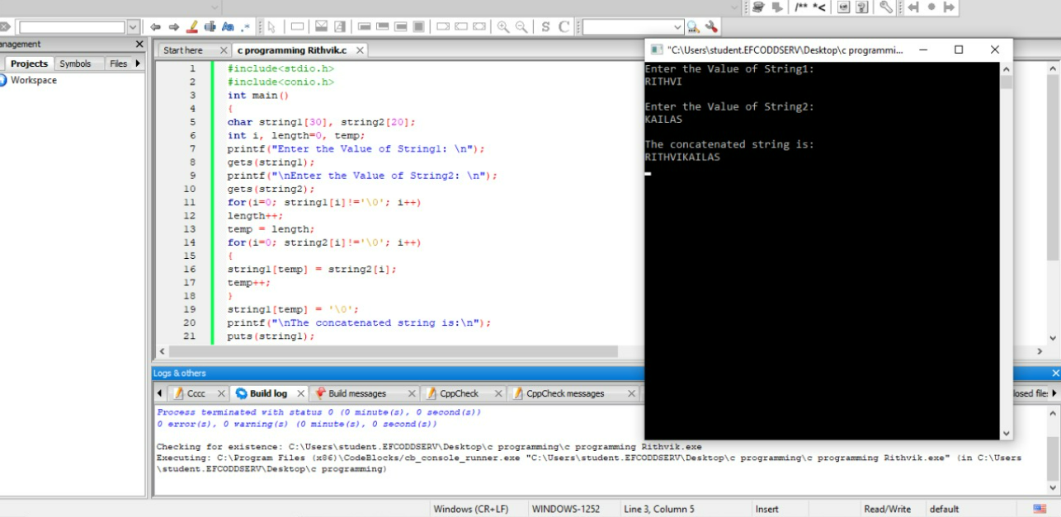

**13.Program to Copy one string to another string.**

#include <stdio.h>

#include <conio.h>

main()

{

char string1[20], string2[20];

int i;

clrscr();

printf("Enter the value of STRING1: \n");

gets(string1);

for(i=0; string1[i]!='\0'; i++)

string2[i]=string1[i];

string2[i]='\0';

printf("\nThe value of STRING2 is:\n");

puts(string2);

getch();

}

**Output:**

Enter the value of STRING1:

c programs are cool

The value of STRING2 is:

c programs are cool

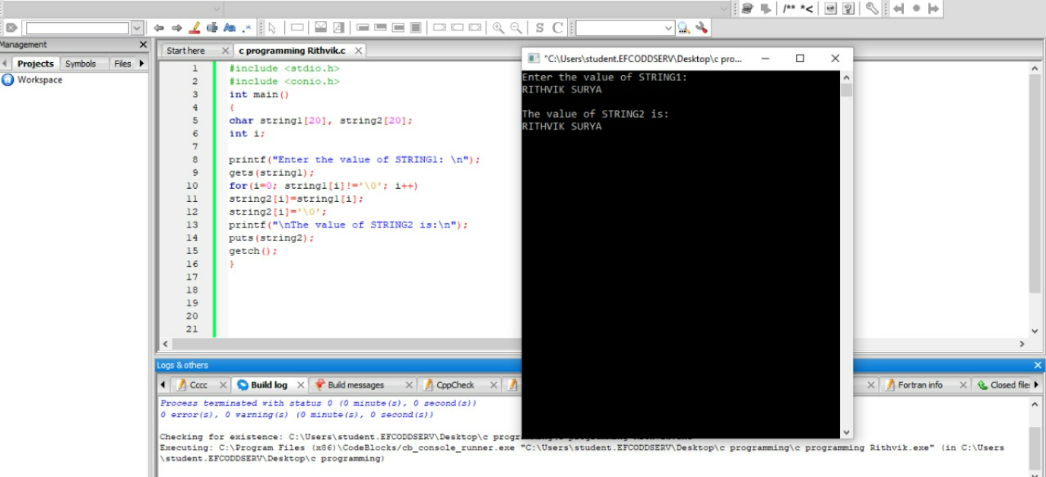

**14. Program to Compare two given strings.**

#include<stdio.h>

main()

{

char string1[15],string2[15];

int i,temp = 0;

clrscr();

printf("Enter the string1 value:\n");

gets(string1);

printf("\nEnter the String2 value:\n");

gets(string2);

for(i=0;string1[i] != ‘\0’;i++) {

if(s1[i] == s2[i])

temp = 1;

else

temp = 0;

}

if(temp==1)

printf("Both strings are same.");

else

printf("Both strings not same.");

getch();

}

**Output1:**

Enter the string1 value:

c programs

Enter the String2 value:

cprograms

Both strings not same.

**Output2:**

Enter the string1 value:

c programs

Enter the String2 value:

c programs

Both strings are same.

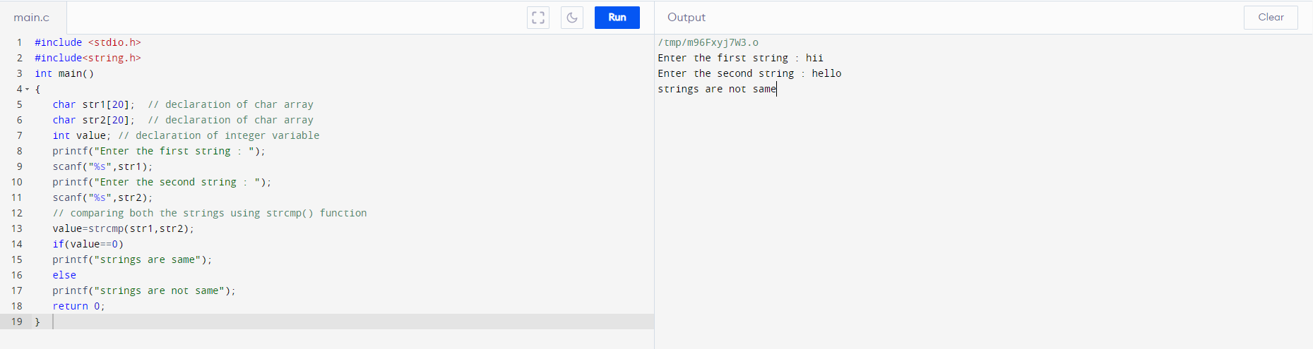

**15. Program to print alphabet set in decimal and character form.**

#include<stdio.h>

main()

{

char c;

clrscr();

printf("\n\n");

for(c=65;c<=122;c=c+1)

{

if(c>90 && c<97)

continue;

printf("%5d - %c",c,c);

}

printf("\n");

getch();

}

**Output:**

65 - A 66 - B 67 - C 68 - D 69 - E 70 - F 71 - G 72 - H

73 -I 74 - J 75 - K 76 - L 77 - M 78 - N 79 - O 80 - P

81 - Q 82 - R 83 - S 84 - T 85 - U 86 - V 87 - W 88 - X

89 - Y 90 - Z 97- a 98 - b 99 - c 100 - d 101 - e 102 - f

103 - g 104 - h 105 - i 106 - j 107 - k 108 - l 109 - m 110 - n

111 - o 112 - p 113 - q 114 - r 115 - s 116 - t 117 - u 118 - v

119 - w 120 - x 121 - y 122 – z

